**Practical No 4 Date:** 11/09/23

**Title:** Write a C++ program using class to process shopping list for a departmental store. The list includes details such as item code no, item name and price of each item and perform the operations like adding, deleting items to the list and printing the total value of an order.

# Description:

A class in C++ is the building block, that leads to Object-Oriented programming. It is a user-defined data type, which holds its own data members and member functions, which can be accessed and used by creating an instance of that class.

Classes are like templates that define common properties or attributes. Objects are instances of a class. Once a class has been defined, we can create any number of objects belonging to that class. Each object is associated with the data or type class with which they are created.

# Declaration of class:

class <class_name>

{

data members; member functions;

};

# Syntax for creating object:

classname objectname;

**Example:** fruit mango;

Hint:

Menu:

Add an item and Quantity Display total value Delete an item

Display all items Exit

class item

{

int itemcode[50]; float itemprice[50]; int count;

public:

void cntzero(); //initialize count to zero

void getitem(); (hint: cin>>itemcode[count]; count++;) //assigns value to data members of class item

void displaysum(); //display total value of all items

void remove(); //ask the user to enter item code and delete the specified item void displayitems(); // displaying items

};

Display all items

Code Quantity price Total

# 567 2 100 200

**678 5 50 250**

# Grand Total: Rs.450

**Total value of inventory: 150**

# Program Code:

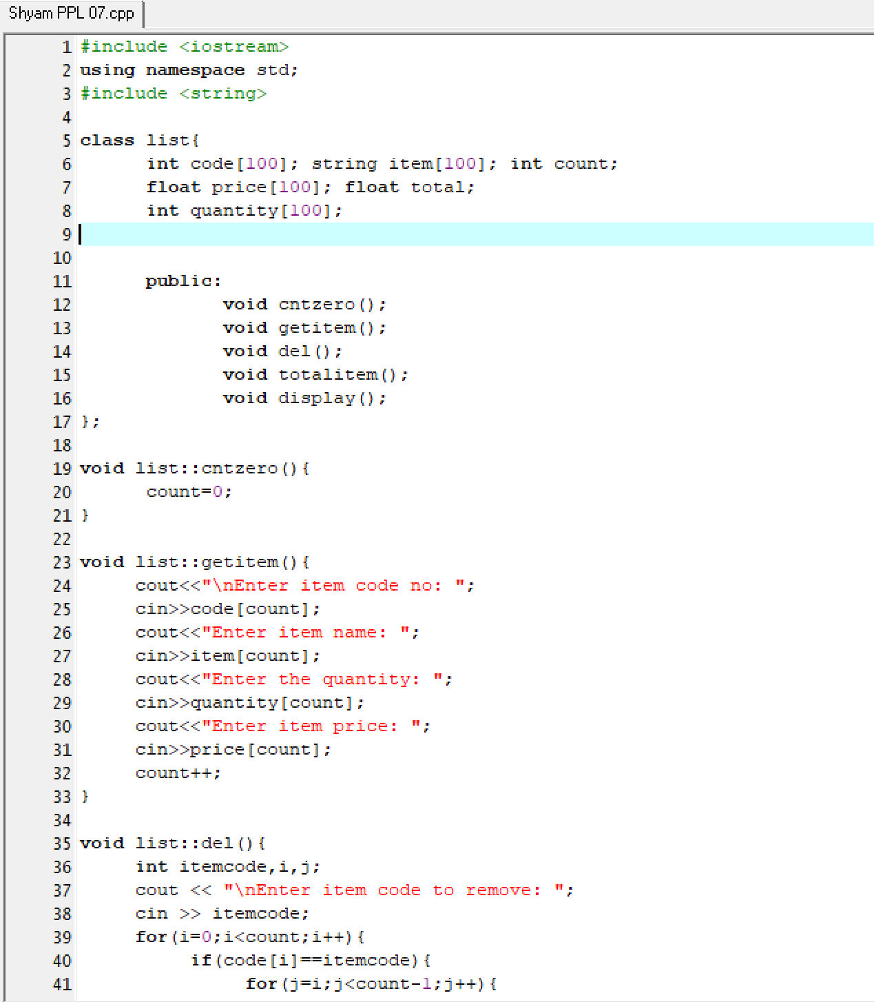

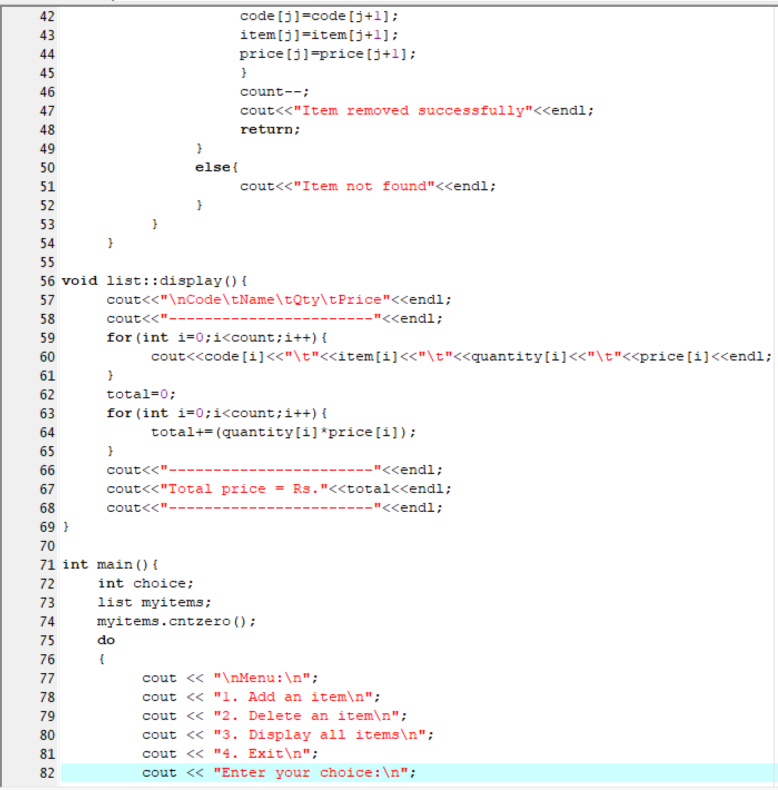

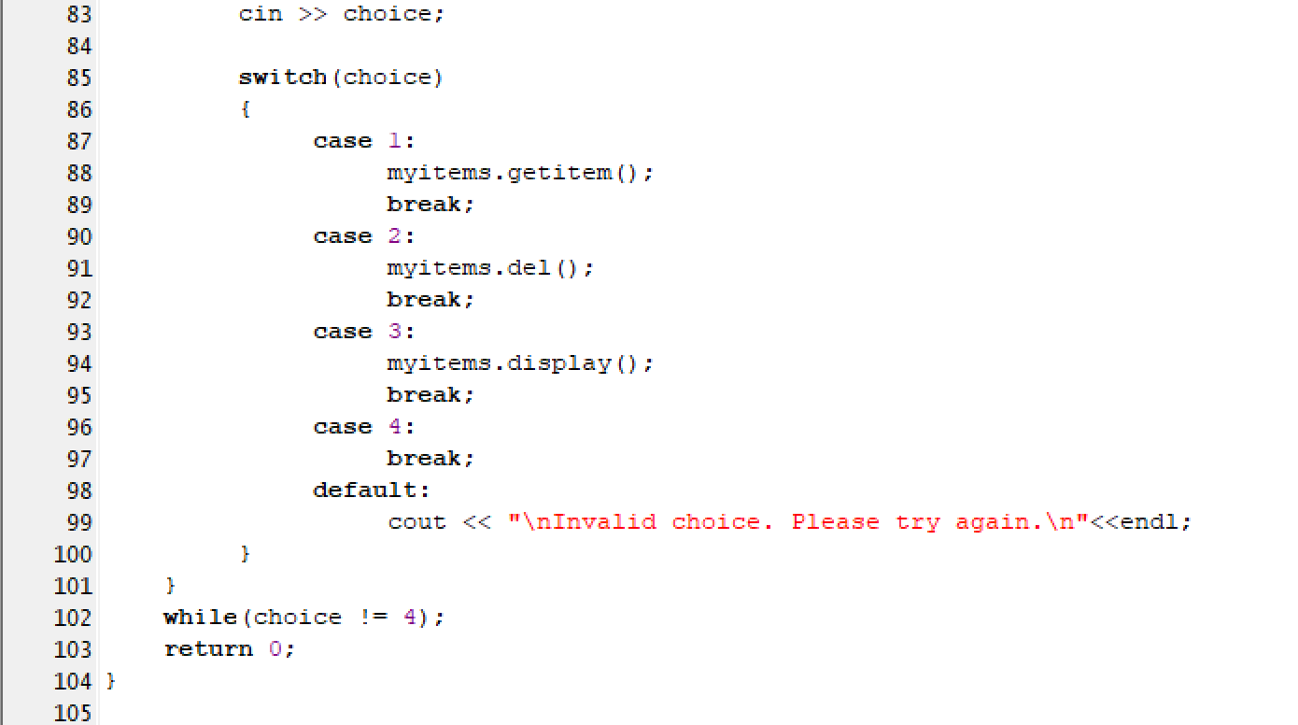

# Input and Output

|  |  |  |
| --- | --- | --- |
| Name | Year of joining | Address |
| Rahul | 2010 | 64C- WallsStreat |
| Samar | 2000 | 68D- WallsStreat |
| Ishita | 2018 | 26B- WallsStreat |

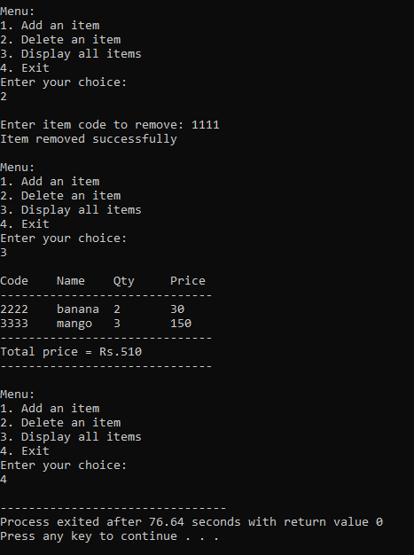

**Conclusion:** Thus we have implemented the concept of classes in C++

**Practice programs:** Write a program that would print the information (name, year of joining, salary, address) of three employees by creating a class named 'Employee'. The output should be follow